Администрация городского округа Среднеуральск

**Муниципальное автономное общеобразовательное учреждение –**

**средняя общеобразовательная школа № 6**

**с углубленным изучением отдельных предметов**

624071, г. Среднеуральск, ул. Лермонтова, 6

(34368) 7-54-17, 7-46-04

**Примерные контрольно – измерительные материалы**

**для проведения промежуточной аттестации**

**по английскому языку за курс 6 класса.**

Reading

My name’s Tony and I’m thirteen. I live in Australia. Our farm is very far from the town of Alice Springs. I get up at 7.00 a.m. I have breakfast with my mother. My father doesn’t eat with us – he works on our farm.

I don’t go out to school. From Mondays to Fridays I study at home. Every week, I have three radio lessons from a school in Alice Springs. I don’t have a teacher at home, but I study from 8 a.m. until 2 p.m. every school day. I use my computer and I ask my teacher questions in emails.

I don’t study in the afternoon, or on Saturdays and Sundays. After my lessons, I phone my friends and I play computer games. In the evening, we eat at 7 p.m. We watch TV for an hour. We go to bed at 9 p.m. – we get up early every day.

Read about Tony’s life in Australia. Answer the questions. Underline the best answer.

|  |  |
| --- | --- |
|  | / 10 |

|  |  |  |
| --- | --- | --- |
| 0 | How old is Tony? | a) He’s thirteen. |
|  |  | b) He’s seven. |
|  |  | c) He’s sixteen. |
| 1 | What does Tony do after he gets up? | a) He wakes up at 7 o’clock. |
|  |  | b) He doesn’t go out to school. |
|  |  | c) He eats breakfast. |
| 2 | Where does Tony study? | a) He studies at school in Alice Springs. |
|  |  | b) He studies at home. |
|  |  | c) He works on the farm. |
| 3 | Does Tony study every day of the week? | a) No, he has three lessons every week. |
|  |  | b) Yes, he studies until 2 p.m. every day of the week. |
|  |  | c) No, he studies five days each week. |
| 4 | Can Tony ask his teacher questions? | a) Yes, he can phone his teacher. |
|  |  | b) Yes, he can send emails to his teacher. |
|  |  | c) Yes, his teacher comes to his home. |
| 5 | What does Tony usually do after supper? | a) He watches television. |
|  |  | b) He listens to his radio lessons. |
|  |  | c) He phones his friends. |

# Use of English

Vocabulary

A Choose and write the adjectives from the box in the correct sentences. You don’t have to use all the adjectives.

|  |  |
| --- | --- |
|  |  |

boring / disappointed / excited / white / interesting / relaxed / hot / yellow / big / comfortable / cold / expensive

0 I am very _*disappointed*__. I got a bad mark in my Maths exam.

1 The tickets for the football match were very _______________ .

2 I’m going to Spain next week. I’m very _______________ .

3 I never feel _______________ before an examination.

4 I don’t like the _______________ weather in the winter.

5 He bought a _______________ and white shirt. / 5

B Match the sentences (1–5) with the people (a–e).

|  |  |
| --- | --- |
|  |  |

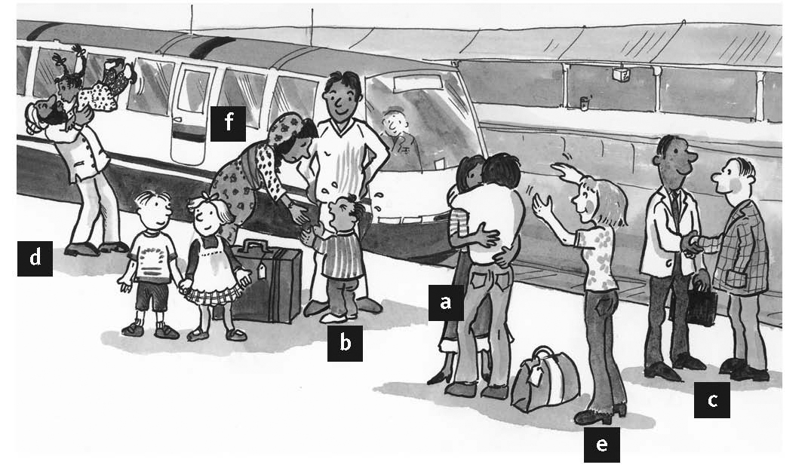

0 He’s smiling. *f*

1 He’s crying. ⬜

2 She’s waving goodbye. ⬜

3 He’s kissing his child goodbye. ⬜

4 They are hugging. ⬜

5 They are shaking hands. ⬜ / 5

Grammar

C Complete the sentences with *going to* and the verbs in brackets.

|  |  |
| --- | --- |
|  | / 5 |

0 She (not study) _*isn’t going to study*_ tonight.

1 I (watch) _________________ this film again tomorrow.

2 He (not use) _________________ his computer in the evening.

3 They (visit) _________________ their aunt on Friday.

4 We (not have) _________________ lunch at home today.

5 Look at the sky. It (rain) _________________ again.

E Match the situations (1–5) with the suggestions (a–f).

|  |  |
| --- | --- |
|  | / 5 |

0 It isn’t going to rain. a) Let’s buy her a present.

1 You like playing tennis. b) Let’s take a taxi home.

2 I’m free in the afternoon. c) Let’s leave the umbrella at home.

3 Josh is hungry. d) Let’s play on Sunday.

4 It’s really late. e) Let’s make him a sandwich.

5 It’s her birthday. f) Let’s go to the cinema.

|  |  |  |
| --- | --- | --- |
| TOTAL |  | / 30 |

27-30 балл – «5»

21-26 баллов – «4»

16-20 баллов – «3»

0-15 баллов – «2»

|  |  |  |
| --- | --- | --- |
|  |  |  |
|  |  |  |

**Текст для аудирования1**

**Kostas:** A cheese sandwich, please.

**Waitress:** I’m sorry. We haven’t got any cheese sandwiches. We’ve got some egg sandwiches.

**Kostas:** OK, an egg sandwich, please. And a coffee.

**Adam:** An orange juice for me, please.

**2**

**Kostas:** Have you got any big t-shirts?

**Man 1:** Yes, I have. Large or extra large?

**Kostas:** Large, please. And have you got any Manchester United football shirts?

**Man 1:** I’m sorry. I haven’t.

**3**

**Adam:** Some envelopes, please.

**Man 2:** Twenty or fifty?

**Adam:** Twenty, please.

**Kostas:** Have you got any stamps?

**Man 2:** Yes, I’ve got books of stamps.

**Kostas:** A book of first class stamps, please.

**Man 2:** Here you are.

**Kostas:** Thanks.